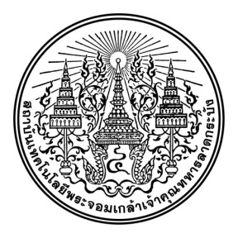
General Education Office
King Mongkut's Institute of Technology Ladkrabang
Examination Final exam Semester 1 Year 2565
Subjects 01006507 Personal Economic Students year Group 101
Exam date Thu 3 Dec 2020 Time 09:30-12:30

Name/Lastname Student's ID
Seat number Room Building
Caution! : Those who cheat on the exam will not receive grades in that term and suspended for 1 semester
Direction
- The exam has 7 pages, 2 parts, total scores 100.
  - Part 1 Multiple choice ....48.... Items Please do it on the answer sheet
  - Part 2 Written part :...10....Items write your answer in answer book.
- Not allowed to keep the examination from exam room.
- Not allowed to bring any materials, books in exam room.
- If you doubt during the exam please raise your hand to ask proctor only. Not allowed to talk with friends in the exam room.

(...................................................)
Instructor

